**Progressive Education Society’s**

**MODERN COLLEGE OF ENGINEERING**

Pune 411005.



**A DSBDA MINI PROJECT REPORT ON**

**“Crop Recommendation Application”**

|  | **By** |
| --- | --- |
| Yash Bhoge | 37003 |
| Vedant Deokar | 37009 |
| Rubal Gajbhiye | 37020 |

Sujay Patil 37054

Under the guidance of

**Mrs. Pallavi Shejwal**

In partial fulfillment of T.E (Information Technology)

Savitribai Phule Pune University PUNE 2022-23

**Progressive Education Society's**

**Modern College Of Engineering, Pune-05.**

**Department of Information Technology**

**2022-23.**

**Certificate**



This is to certify that, project entitled “**Crop Recommendation Application**”, Submitted by **Yash Bhoge(37003), Vedant Deokar(37009), Rubal Gajbhiye(37020), Sujay Patil(37054)**  is record of bonafide work carried out by them, underthe guidance of **Mrs. Pallavi Shejwal**, in fulfillment of the requirement for the award of the T.E. of Bachelor of Engineering in **Information Technology,** Savitribai Phule Pune University.

**Mrs. Pallavi Shejwal**

**Dr. Prof. Mrs. S. D. Deshpande**

**GUIDE**

**H.O.D (IT)**

Date :23/05/2023

Place: Pune

**ACKNOWLEDGEMENT**

We are taking this opportunity to express our profound gratitude for the personal involvement and constructive criticism provided beyond technical guidance during the seminar to our guide **Mrs. Pallavi Shejwal** of the INFORMATION TECHNOLOGY department. We are extremely grateful for giving us immediate access to all the software documents , college hardware and equipment , also for suggesting technology requirements along with its benefits and usage at all odd times whenever we asked for it.

We shall ever be grateful to her for the encouragement and suggestions given by her from time to time. I would like to thank **Dr. Prof. Mrs. S. D. Deshpande** (H. O. D. of Information Technology department) for providing the necessary facilities during the period of working of this seminar.

We would also like to express our gratitude towards our principal **Dr. Prof. Mrs. K.R. Joshi** for giving us this great opportunity. Without her support and suggestions, this project wouldnot have been completed.

Last but not the list; we would like to thank our parents and friends for all the encouragement and support we received from them. With all respect and gratitude, we would like to thank all the people who helped, encouraged, guided and supported me throughout the duration of the seminar , directly or indirectly.

**ABSTRACT**

The Crop Recommendation application is an innovative solution designed to assist farmers in making informed decisions about crop selection. By integrating machine learning algorithms and agricultural data, the application analyzes various factors such as soil type, climate conditions, historical crop performance, and market trends. Leveraging this information, the application provides personalized crop suggestions to farmers, optimizing their agricultural productivity and profitability. By utilizing cutting-edge technology and harnessing the power of data analysis, the Crop Recommendation application empowers farmers with valuable insights, enabling them to make well-informed decisions and improve their overall crop yield and financial outcomes.

**INDEX**

| **Sr.no.** | **Contents** | **Page** |  |
| --- | --- | --- | --- |
|  |  | **no.** |  |
| 1 | Project Title | 1 |  |
|  |  |  |  |
| 3 | Acknowledgement | 3 |  |
|  |  |  |  |
| 2 | Abstract | 4 |  |
|  |  |  |  |
| 4 | Index | 5 |  |
|  |  |  |  |
| 5 | Introduction |  |  |
|  | a. Motivation | 6 |  |
|  | b. Need application |  |  |
|  |  |  |  |
|  | Literature Survey | **7** |  |
|  |  |  |  |
| 6 | Design Details & Implementation |  |  |
|  | a. Dataset Description | 9 |  |
|  | b. Dataset Preprocessing |  |
|  |  |  |
|  | c. Prediction and Visualization |  |  |
| 7 | Conclusion | 16 |  |
|  |  |  |  |
| 8 | References | 17 |  |
|  |  |  |  |

**CROP RECOMMENDATION APPLICATION**

**Introduction**

In recent times, it has become inevitable to use technology to create awareness about cultivation. The seasonal climatic conditions are also being changed against the fundamental assets like soil, water and air which lead to insecurity of food. In a scenario, crop yield rate is falling short of meeting the demand consistently and there is a need for a smart system which can solve the problem of decreasing crop yield. Therefore, to eliminate this problem, we propose a system which will provide crop selection based on economic and environmental factors to reap the maximum yield out of it for the farmers which will sequentially help meet the elevating demands for the food supplies in the country.

The proposed system uses machine learning to make the predictions.

The system will provide crop yield and crop selection based on weather attributes suitable for the crop to get the maximum yield out of it for the farmers. The system makes predictions of the productions of crops by studying the factors such as rainfall, temperature, area (in hectares), season, etc.

**Literature Survey**

Machine learning approach for forecasting crop yield based on climatic parameters:-

S. Veenadhari, Dr. Bharat Misra & Dr. CD Singh Publication:

International Conference on Computer Madhya Pradesh. The selection of districts has been made based on the area under that particular Communication and Informatics (ICCCI 2014), Jan, 2014

In this paper, the study was aimed to develop a website for finding out the influence of climatic parameters on crop production in selected districts of crop. Based on this criteria first top five districts in which the selected crop area is maximum were selected. The crops selected in the study were based on the predominant crops in the selected district. The selected crop included: Soybean, Maize, Paddy and Wheat.

The yield of these crops was tabulated for continuous 20 years by collecting the information from secondary sources. Similarly for the corresponding years climatic parameters such as Rainfall, Maximum & Minimum temperature, Potential Evapotranspiration, Cloud cover,

Wet day frequency were also collected from the secondary sources.

This paper focuses on relevance approach analysis to ensure accurate prediction. This is achieved by calculating information gain of each attribute and comparing them. However, it does not include the analysis of other supervised machine learning algorithms like random forest and linear regression.

Prediction of Crop Yield Using Machine Learning Author :- Rushika Ghadge, Juilee Kulkarni, Pooja More, Sachee Nene, Priya R L Publication: International Research Journal of Engineering and Technology (IRJET) Volume 05, Issue 02, Feb-2018 This paper states, most of the existing systems are hardware based which makes them expensive and difficult to maintain and lack to give accurate results. Some systems suggest crop sequence depending on yield rate and market price. In this paper, the system proposed tries to overcome these drawbacks and predicts crops by analyzing structured data.

Being a totally software solution, it does not allow maintenance factor to be considered much. Also the accuracy level would be high as compared to hardware based solutions, because components like soil composition, soil type, pH value, weather conditions all come into picture during the prediction process.

The paper concludes that the system uses supervised and unsupervised Machine learning algorithms and gives best results based on accuracy.

**Design Details and Implementation**

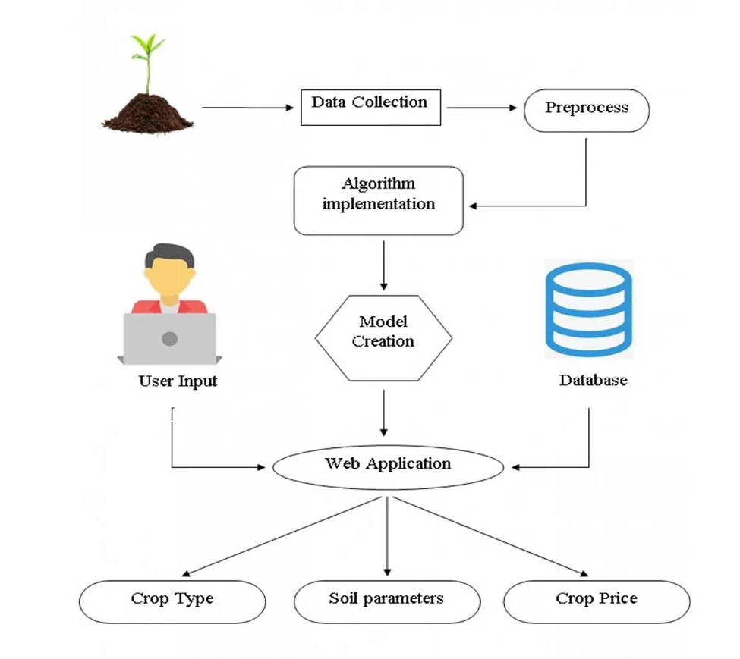

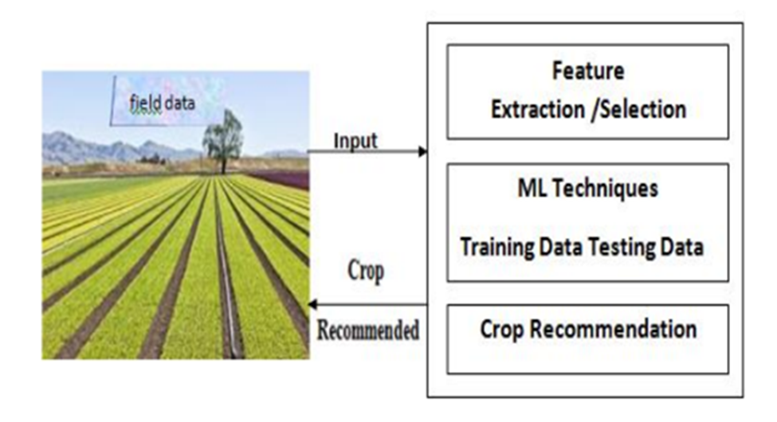

This algorithm mostly used in social science and the dependent variable is categorical type. In this current study the predicated variable is the name of crop is categorical type and its value more than three outcomes with proper ordering so here we use ordinal logistic regression algorithm for correct prediction of outcome.

The sigmoid function also called as logistic function, it is used to calculate correct prediction values. If the value of z is positive then predicted value is 1 and if it goes to negative then predicted value is considered as 0.

And if the outcome of the sigmoid function is greater than

0.5 then it label as 1 or positive and if it is less than 0.5 then this module returns the predicted production of crops based on the user's input. If the user wants to know the production of a particular crop, the system takes the crop as the input as well. Else, it returns a list of crops along with their production as output.

These are the following steps of the algorithm implemented:

• Step 1: Choose the functionality i.e., crop prediction or yield prediction.

• Step 2: If the user chooses crop prediction:

o Take soil type and area as inputs.

o These values are given as input to the Regression Model in the backend and the corresponding predictions are returned.

o The algorithm returns a list of crops along with their production predicted.

Depending on the correct prediction each algorithm suggest the most profitable model or crop to the farmer depending on the different attributes. UI is created with Streamlit library .

If you are working for a client you probably need to deploy the model in the client's environment, but if you are working on a project that needs to be publicly available you should use technology to deploy it on the web. Streamlit is the best lightweight technology for web deployment.

**Dataset Preprocessing**

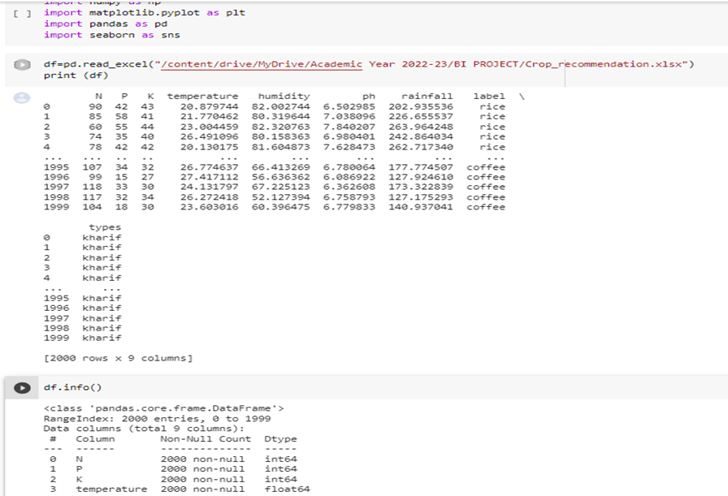

**Correlation Matrix Visualization**

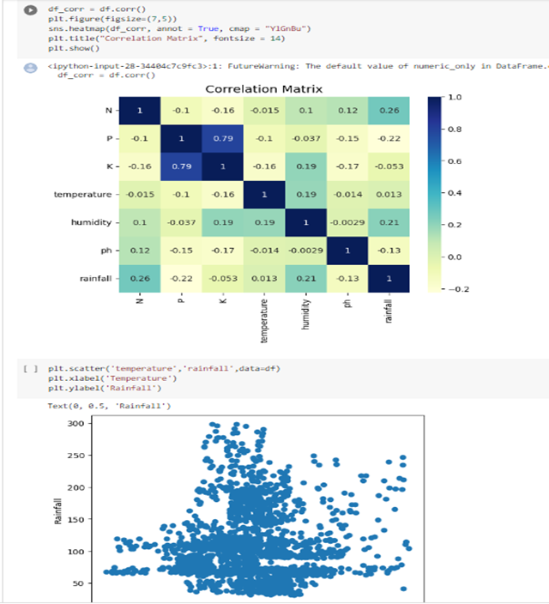

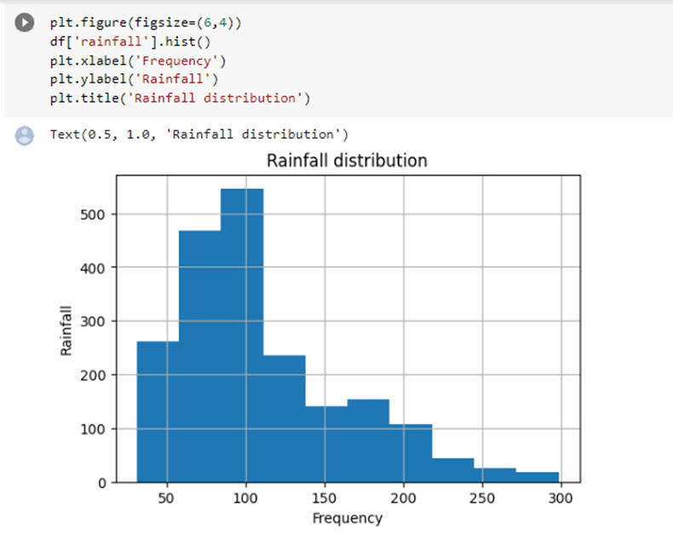

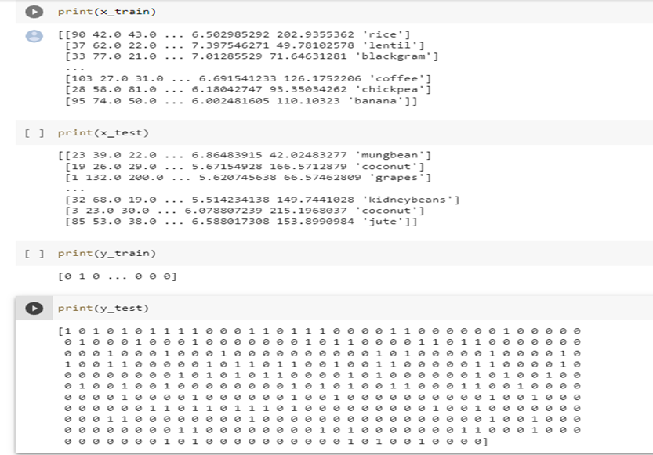

**Front-End Design**

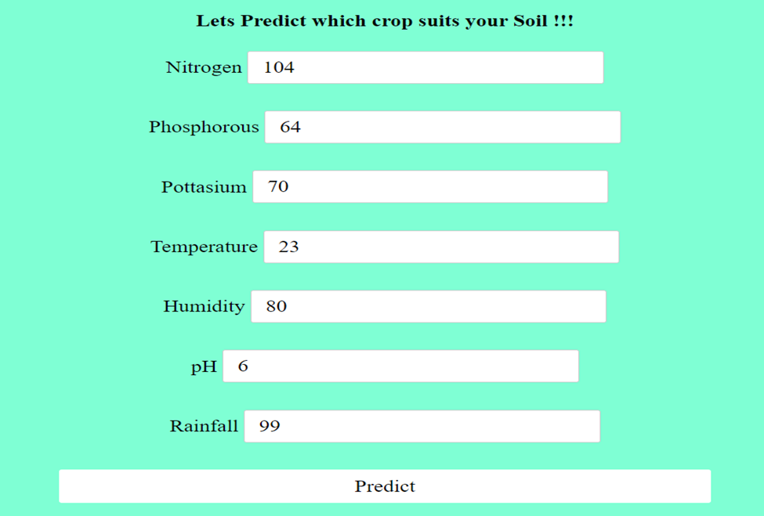

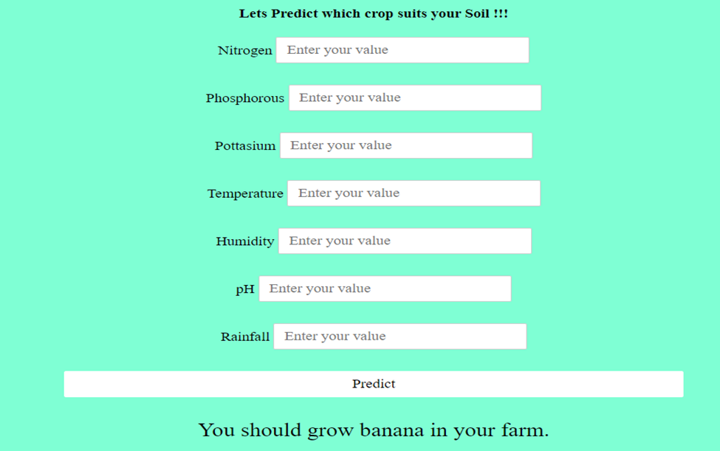

**CONCLUSION**

This system is proposed to deal with the increasing rate of farmer

suicides and to help them to grow financially stronger. The Crop Recommender system helps the farmers to predict the yield of a given crop and also helps them to decide which crop to grow. Moreover, it also tells the user the right time to use the fertiliser.

Appropriate datasets were collected, studied and trained using machine learning tools. The system tracks the user's location and fetches needed information from the backend based on the location.

Thus, the user needs to provide limited information like the soil type and area. This system contributes to the field of agriculture.

**REFERENCES**

1)Agricultural Decision Support Systems: A Review" by S. L. Amoroso, A. F. Sage, and G. D. Thériault (2009).

2) Agricultural Crop Recommendation System using Data Mining Techniques" by V. H. Patel, P. R. Kanani, and M. R. Parmar (2012).

3) Crop Yield Prediction using Machine Learning: A Review" by S. Karimi and M. K. Khedher (2020).

4) Application of Data Mining Techniques in Agriculture" by P. G. Gawande and R. S. Chaudhari (2017).

5) A Review of Crop Recommendation Systems for Precision Agriculture" by A. Tarkhanyan, A. Heinemann, and C. Stachniss (2017).